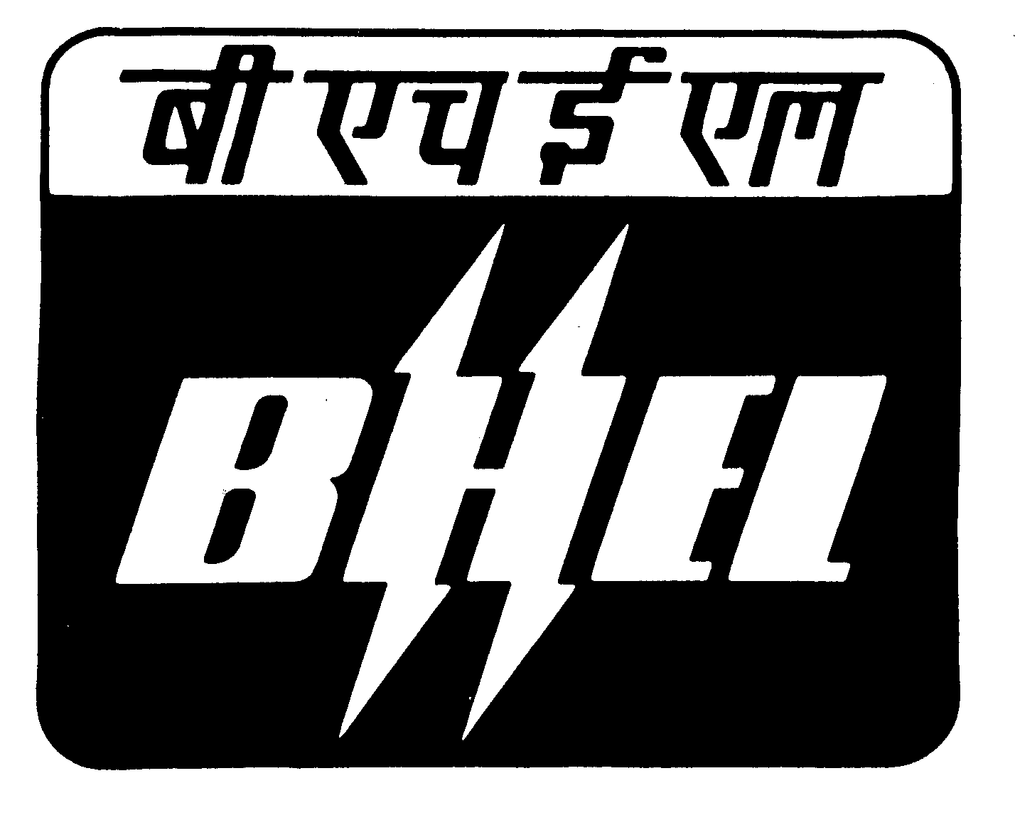
BHARAT HEAVY ELECTRICALS LIMITED

(A Government of India Undertaking)
Ramachandrapuram, Hyderabad – 502 032. INDIA
PURCHASE DEPARTMENT (CG).
Ph.Nos: 0091-040-23182250

Fax.Nos.0091-40-23020173

Capital Purchase Corrigendum No : 1/09

With reference to Tender Nos : M208CG8A0085/BRK published on 07/08/2008 in The Hindu, The Times of India, Amar Ujhala (Hindi) and also Published in Indian Trade Journal 20/08/2008 issue, for procurement of Narrow Gap Welding Machine for BHEL-Hyderabad, there is a change in specifications, which are given below. For complete details please visit our website: www.bhel.com. Interested parties may submit their offers in two part bid, if they have not participated already, on or before 16/06/2009 before 11.00 AM.

Tender No: M208CG8A0085/BRK NARROW GAP WELDING MACHINE

Sl No | Clause no: | NIT requirement | Amendment
1 | 2.2 | Boom Horizontal Travel: 4000mm  Welding speed : 0.1 - 2.0 m/ min  Speed accuracy +/- 0.5cm/min  AC motor & VFD drive with brake  Rack & pinion drive mechanism. | Boom Horizontal Travel: 4000mm  Welding speed : 0.1 - 2.0 m/ min  Speed accuracy +/- 0.5cm/min  AC motor & VFD drive with brake  Rack & pinion drive mechanism / Chain & counter weight mechanism
2 | 3.3 | Wire feeder: AC motor & VFD drive with built in gear box. | Wire feeder: AC motor & VFD drive with built in gear box. / DC motor with DC drive with built-in gear box.
3 | 3.16 | AC motors with VFD driven motorised heavy duty slides 300X 500 mm in conjunction with edge tracker that secures the positioning of the head within +/- 1.5mm deviation. | AC motors with VFD driven / DC motor and DC drive - motorised heavy duty slides 300X 500 mm in conjunction with edge tracker that secures the positioning of the head within +/- 1.5mm deviation.

Sr. Manager/ Pur-CG

