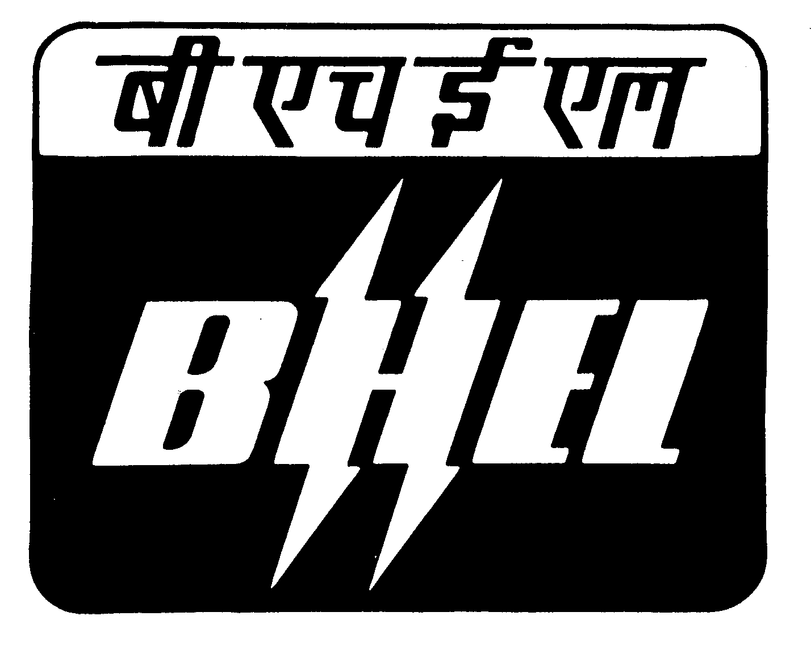
BHARAT HEAVY ELECTRICALS LIMITED
Ramachandrapuram, Hyderabad - 502 032
Phones : 040 - 23183411 , FAX No : 040- 23021940
Email: barad@bhelhyd.co.in
CENTRAL DESPATCH CELL

Ref.: HY/CDC/HT/C-1/’10 DATE: 07-4-2010
To:
All Bidders
Sub.: CORRIGENDUM and Extension of Due date for offer submission

NIT No. 8010 dated 19-3-2010 &
Tender Notice Ref.: CDC/Shipping/HT/2010-’11 dated 19-03-2010

With reference to above tender i.e “ TRANSPORTATION OF EQUIPMENT BY HYDRAULIC TRAILERS ” the following are the corrigendums issued.

AA | FOR | READ AS
First sentence in Clause-18 on Page No. 6 | FR- 9E & 9FA Gas Turbine and Generator consignments shall be transported only on Goldhoffer or other equivalent make imported Axles and Volvo 520 prime movers. | FR- 9E & 9FA Gas Turbine and Generator consignments shall be transported only on Hydraulic Axles having a minimum net payload capacity of 16 MT & capable of one and a half file configuration and by Volvo 520 prime movers.

BB: Consignee addresses are appended in a seperate Excel – sheet titled
Hyd-ADD.

CC: EXTENSION OF DUE DATE OF OFFER SUBMISSION :

The due date for submission of Tender has been re scheduled to 23-4-1010, 14.00 Hrs. Technical bids shall be opened on 23-4-2010 at 14.30 Hrs. All other terms and conditions of the tender specification shall remain unaltered unless expressly amended by BHEL in writing.
Bidders are requested to submit as a part of Technical Bid, a copy of this corrigendum duly countersigned by the authorized signatory and stamped with official seal as a token of Bidder’s unqualified acceptance of this corrigendum.
Sd/-
Sr.Dy.General Manager / CDC

